This simple circuit mixes two or more channels into one channel (eg. stereo into mono). The circuit can mix as many or as few channels as you like and consumes very little power. The mixer is shown with two inputs, but you can add as many as you want by just duplicating the "sections" which are clearly visible on the schematic.

Schematic
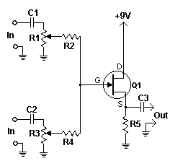

Parts

Part | Total Qty. | Description
R1, R3 | 2 | 10K Pot
R2, R4 | 2 | 100K 1/4 W Resistor
R5 | 1 | 6.8K 1/4 W Resistor
C1, C2, C3 | 3 | 0.1uF Capacitor
Q1 | 1 | 2N3819 Junction FET
MISC | 1 | Wire, Shielded (Metal) Case, Phono Or Other Plug For Output

